Interference: When two light waves from different coherent sources meet together, then the distribution of energy due to one wave is disturbed by the other. This modification in the distribution of light energy due to super position of two light waves is called "Interference of light".
CONDITIONS FOR INTERFERENCE
The two sources of light should emit continuous waves of same wavelength
and same time period i.e. the source should have phase coherence.
The two sources of light should be very close to each other.
The waves emitted by two sources should either have zero phase difference
or no phase difference.
COHERENT SOURCES
Those sources of light which emit light waves continuously of same wavelength, and time period, frequency and amplitude and have zero phase difference or constant phase difference are coherent sources.
TYPES OF INTERFERENCE
There are two types of interference.
Constructive interference.
Destructive interference.
CONSTRUCTIVE INTERFERENCE
When two light waves superpose with each other in such a way that the crest of one wave falls on the crest of the second wave, and trough of one wave falls on the trough of the second wave, then the resultant wave has larger amplitude and it is called constructive interference.
CONDITIONS FOR CONSTRUCTIVE INTERFERENCE
For constructive interference, path difference between two waves is, mλ
i.e. path difference = mλ
or, path difference = 0,  λ, 2λ  …..
where m = order = 0, +_1, +_2, +_3,…..
The principle of superposition of waves states that when two or more waves are incident on the same point, the total displacement at that point is equal to the vector sum of the displacements of the individual waves. If a crest of a wave meets a crest of another wave of the same frequency at the same point, then the magnitude of the displacement is the sum of the individual magnitudes – this is constructive interference.
DESTRUCTIVE INTERFERENCE
If a crest of one wave meets a trough of another wave then the magnitude of the displacements is equal to the difference in the individual magnitudes – this is known as destructive interference.
CONDITIONS FOR DESTRUCTIVE INTERFERENCE
For constructive interference, path difference between two waves is, mλ
i.e. path difference = (m+1/2)λ
or, path difference = λ/2, 3λ/2  …..
where m = order = 0, +_1, +_2, +_3,…..
combined  waveform | 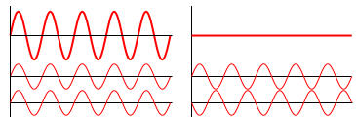
wave 1
wave 2
 | Constructive interference | Destructive interference
Constructive interference occurs when the phase difference between the waves is a multiple of 2π, whereas destructive interference occurs when the difference is π, 3π, 5π, etc. Constructive interference occurs when the waves are in phase, and destructive interference when they are half a cycle out of phase.
Diffraction of Light:
Diffraction effect depends upon the size of obstacle. Diffraction of light takes place if the size of obstacle is comparable to the wavelength of light. Light waves are very small in wavelength, i.e. from 4 x 10⁻⁷ m to 7 x 10⁻⁷ m. If the size of opening or obstacle is near to this limit, only then we can observe the phenomenon of diffraction.
Diffraction of light can be divided into two classes:
Fraunhoffer diffraction.
Fresnel diffraction.
FRAUNHOFFER DIFFRACTION

In Fraunhoffer diffraction
Source and the screen are far away from each other.
Incident wave fronts on the diffracting obstacle are plane.
Diffracting obstacle give rise to wave fronts which are also plane.
Plane diffracting wave fronts are converged by means of a convex lens to produce diffraction pattern.
FRESNEL DIFFRACTION
In Fresnel diffraction
Source and screen are not far away from each other.
Incident wave fronts are spherical.
Wave fronts leaving the obstacles are also spherical.
Convex lens is not needed to converge the spherical wave fronts.

IFFRACTION GRATING
Diffraction grating: A diffraction grating is an optical device consists of a glass or polished metal surface over which thousands of fine, equidistant, closely spaced parallel lines are been ruled.
INCIPLE
Its working principle is based on the phenomenon of diffraction. The space between lines act as slits and these slits diffract the light waves there by producing a large number of beams which interfere in such away to produce spectra.
GRATING ELEMENT
Distance between two consecutive slits(lines) of a grating is called grating element. If 'a' is the separation between two slits and 'b' is the width of a slit, then grating element 'd' is given by;
d = a + b
_{OR}
d = length of grating/no. of lines

Consider two parallel rays of light r1 and r2 falling on a grating .After passing through slits they are diffracted and brought to focus on a screen at point B by using a convex lens.. Draw a perpendicular 'pq' from P on r1. Ray (1) covers a distance "rq" more than ray (2).
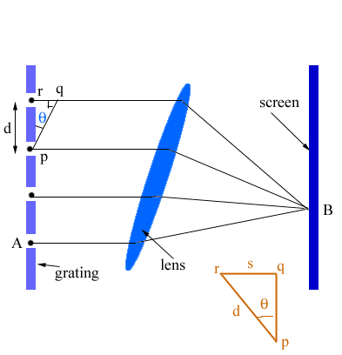
Now consider right angled Δrpq
rq/rp = sinθ
Or rq= rp sinθ
But rp = (a+b)
(a+ b ) = d (grating element)
rq = dsinθ -----(1)
Where rq= path difference of r1 and r2.
We know that for constructive interference at point 'B', path difference between r1 and r2 will be 0, λ, 2λ, 3λl, …….,mλl.
Therefore, rq = mλ for bright point
Putting this value in equation (1), we get
mλ = dsinθ where m = order
This equation is called "grating equation" and is used to determine he wavelength of light.
CONCLUSION
'm' is called the order of grating and it is the number of bright or dark fringe obtained on the screen.
For m=0 , θ=0, central bright maxima of zeroth order.
m=1 , θ=θ1, 1st order bright maxima (path difference = λ)
m=2 , θ=θ2, 2nd order bright maxima (path difference = 2λ)
With the increase in 'm', fringes of decreasing width and less brightness are obtained.
No order of line is possible at θ>90º.
GRATING SPECTRA
Spectra of different orders are obtained symmetrically on both sides of zeroth
order image.
Spectral lines are almost straight and quite sharp.
Spectral colors are in the order.
The spectral lines are more and more dispersed as we go to higher orders.
Most of the incident intensity goes to zero^{th} order and rest of it is distributed
among the other orders.

What are the difference between diffraction and interference of light?
- Two separate wave fronts originating from two coherent sources produce interference. Secondary wavelets originating from different parts of the same wave front constitute diffraction. Thus the two are entirely different in nature.
- The region of minimum intensity is perfectly dark in interference.
In diffraction they are not perfectly dark.
- Width of the fringes is equal in interference. In diffraction they are never equal.
- The intensity of all positions of maxima are of the same intensity in interference.
In diffraction they do vary.
- Interference happens when there are two waves that will intersect with each other. Interference can't happen with only one wave, diffraction can happen with only one wave.
- Diffraction happens around edges or holes, interference happens at the intersection of two waves
- Interference affects the waves. It can be either constructive or destructive. Diffraction does not affect the waves it only spreads or turn around.
- Interference does not contribute a lot in practical applications. It is mostly avoided especially when sound waves are concerned. Diffraction is very helpful. Because of it we can hear even if we are behind the tree or a wall
We should point out that there is not much of a difference between the phenomenon of interference and diffraction, indeed, interference corresponds to the situation when we consider the superposition of waves coming out from a number of point sources and diffraction corresponds to the situation when we consider waves coming out from an area sources like a circular or rectangular aperture or even a large number of rectangular apertures (like the diffraction grating).
Diffraction occurs when a wave encounters an obstacle or a slit these characteristic behaviors are exhibited when a wave encounters an obstacle or a slit that is comparable in size to its wavelength, whereas Interference is the phenomenon where waves meet each other and combine additively or substractively to form composite waves. In a sense there are similarities in the fact that both phenomena from a given wave produce other waves (with in general different frequency or phase and/or amplitude etc.). The main difference is the mechanism, diffraction involves a wave and some obstacle or object which deflects the wave or bends it and intereference involves a wave which combine with other waves. In physical experiments both these phenomena can happen and be part of the same overall phenomenon.

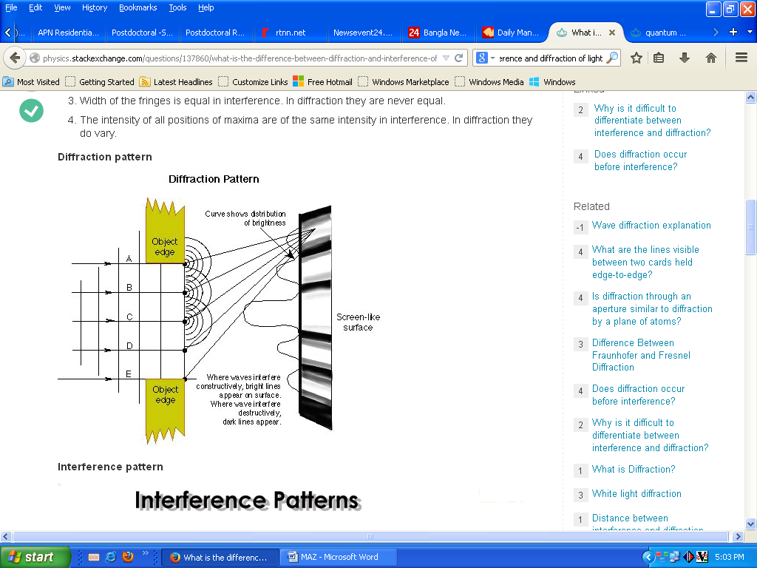

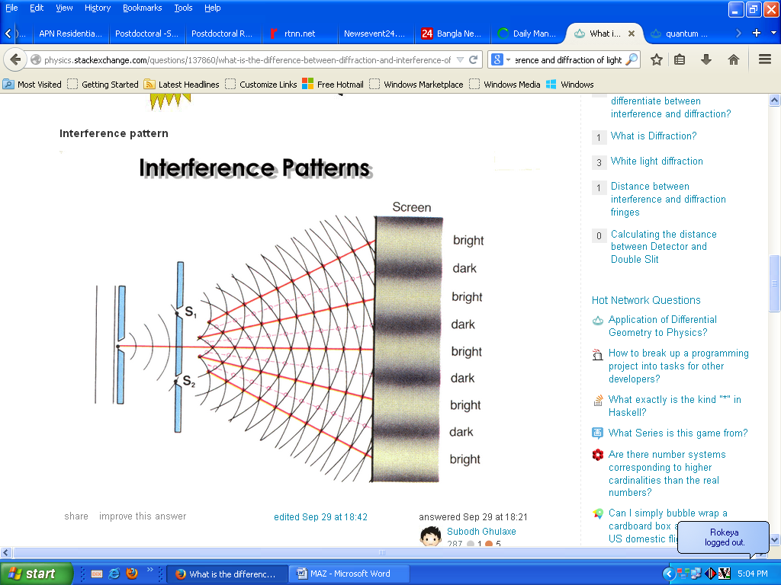
The (geometrical) type of fringes can be similar in some cases to both phenomena or different, i dont think there is a general pattern here. Diffraction is the tendency of a wave emitted from a finite source or passing through a finite aperture to spread out as it propagates. Diffraction results from the interference of an infinite number of waves emitted by a continuous distribution of source points. If light is incident onto an obstacle which contains two very small slits a distance d apart, then the wavelets emanating from each slit will interfere behind the obstacle. Waves passing through each slit are diffracted and spread out. At angles where the single slit diffraction pattern produces nonzero intensity, the waves from the two slits can now constructively or destructively interfere.

Polarization: A light wave that is vibrating in more than one plane is referred to as unpolarized light. Polarized light waves are light waves in which the vibrations occur in a single plane. The process of transforming unpolarized light into polarized light is known as polarization. There are a variety of methods of polarizing light. The four methods discussed on this page are: Polarization by Transmission, Polarization by Reflection, Polarization by Refraction, Polarization by Scattering.

Figures of Interference, diffraction and diffraction grating

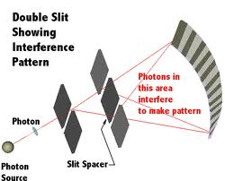

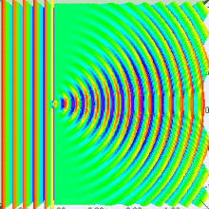
Numerical approximation of diffraction pattern from a slit of width equal to wavelength of an incident plane wave in 3D spectrum visualization
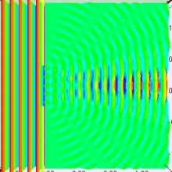
Numerical approximation of diffraction pattern from a slit of width equal to five times the wavelength of an incident plane wave in 3D spectrum visualization
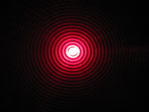
Diffraction of red laser beam on the hole
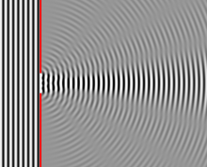
Numerical approximation of diffraction pattern from a slit of width four wavelengths with an incident plane wave. The main central beam, nulls, and phase reversals are apparent.

Diffraction Grating Figure
A diffraction grating is the tool of choice for separating the colors in incident light.

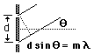 | The condition for maximum intensity is the same as that for a double slit. However, angular separation of the maxima is generally much greater because the slit spacing is so small for a diffraction grating.

SPECIFIC OBJECTIVES
To understand how a diffraction grating works; to understand the diffraction grating equation.

EQUIPMENT
Spectrometer, diffraction grating, mercury light source, high-voltage power supply.

BACKGROUND
A diffraction grating is made by making many parallel scratches on the surface of a flat piece of transparent material. It is possible to put a large number of scratches per centimeter on the material, e.g., the grating to be used has 6,000 lines/cm on it. The scratches are opaque but the areas between the scratches can transmit light. Thus, a diffraction grating becomes a multitude of parallel slit sources when light falls upon it.
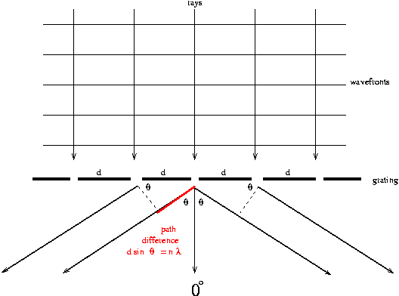

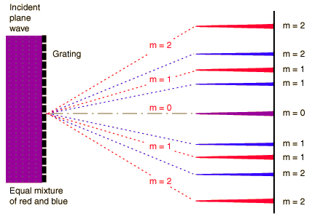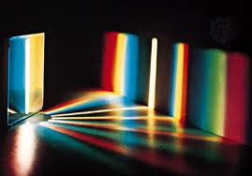
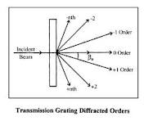
A parallel bundle of rays falls on the grating. Rays and wavefronts form an orthogonal set so the wavefronts are perpendicular to the rays and parallel to the grating as shown. Utilizing Huygens' Principle, which is that every point on a wavefront acts like a new source, each transparent slit becomes a new source so cylindrical wavefronts spread out from each. These wavefronts interfere either constructively or destructively depending on how the peaks and valleys of the waves are related. If a peak falls on a valley consistently (called destructive interference), then the waves cancel and no light exists at that point. On the other hand, if peaks fall on peaks and valleys fall on valleys consistently (called constructive interference), then the light is made brighter at that point.
Consider two rays which emerge making an angle with the straight through line. Constructive interference (brightness) will occur if the difference in their two path lengths is an integral multiple of their wavelength () i.e., difference = n where n = 1, 2, 3, ... Now, a triangle is formed, as indicated in the diagram, for which
n = d sin( )
and this is known as the DIFFRACTION GRATING EQUATION. In this formula is the angle of emergence (called deviation, D, for the prism) at which a wavelength will be bright, d is the distance between slits (note that d = 1 / N if N, called the grating constant, is the number of lines per unit length) and n is the "order number", a positive integer (n = 1, 2, 3, ...) representing the repetition of the spectrum.
Thus, the colors present in the light from the source incident on the grating would emerge each at a different angle since each has a different wavelength . Furthermore, a complete spectrum would be observed for n = 1 and another complete spectrum for n = 2, etc., but at larger angles.
Also, the triangle formed by rays to the left of 0º is identical to the triangle formed by rays to the right of 0º but the angles _{R} and _{L} (Right and Left) would be the same only if the grating is perpendicular to the incident beam. This perpendicularity is inconvenient to achieve so, in practice, _{R} and _{L} are both measured and their average is used as in the grating equation.

PROCEDURE

Calibrating the Spectrometer
Read and follow the procedures for calibrating the spectroscope found in the previous experiment. The calibration can be performed with the grating in place on the table.

Measuring
- CAUTION: The diffraction grating is a photographic reproduction and should NOT be touched. The deeper recess in the holder is intended to protect it from damage. Therefore, the glass is on the shallow side of the holder and the grating is on the deep side.
- Place the grating on the center of the table with its scratches running vertically, and with the base material (glass) facing the light source. In this way, one can study diffraction without the complication of refraction (recall from the previous lab how light behaves when traveling through glass at other than normal incidence). Fix the grating in place using masking tape.
- Rotate the table to make the grating perpendicular to the incident beam by eye. This is not critical since the average of _{R} and _{L} accommodates a minor misalignment.
- Affirm maximum brightness for the straight through beam by adjusting the source-slit alignment. At this step, the slit should be narrow, perhaps a few times wider than the hairline. Search for the spectrum by moving the telescope to one side or the other. This spectrum should look much like that observed with the prism except that the order of the colors as you move away from zero degrees is reversed.
- Search for the second- and third-order spectra. Do not measure the higher-order angles, but record the order of colors away from zero degrees.
- For each of the seven colors in the mercury spectrum, measure the angles _{R} and _{L} to the nearest tenth of a degree by placing the hairline on the stationary side of the slit.

Analysis
- Average the right and left angles for each color.
- Use the grating equation with d=(1/6000) cm to find the wavelength for each color. Remember that 10⁸ angstrom = 1 cm.
- Calculate the percent deviation for each wavelength using
% deviation = (data-theory)/theory x 100%
where "theory" is the tabulated wavelength from the last experiment. Do not ignore the sign; it contains information. A positive % deviation means that the value is above the theory; a negative % deviation means that the value is below the theory.
- Do you notice any systematic problems in your seven % deviations?
- Use the grating equation with the tabulated values of from last time and your measured values of to calculate seven different values of N, the grating constant (N=1/d).
- Average the seven values of N. For the error on N, use the standard deviation on the mean (SDOM). Compare your answer to the accepted value of 6000 lines/cm. Does your value of N agree with the manufacturer's value within the error range? See Taylor page 5 if you are confused.
- What could be causing any discrepancy?
- Why is it necessary that the base side of the grating face toward the light source? Draw a ray diagram for the two cases: a) base toward the source (correct) and b) grating toward the source (incorrect).
- A certain color emerges at 15º in the first-order spectrum. At what angle would this same color emerge in the second order if the same source and grating are used?

Mechanism
The principle of superposition of waves states that when two or more waves are incident on the same point, the total displacement at that point is equal to the vector sum of the displacements of the individual waves. If a crest of a wave meets a crest of another wave of the same frequency at the same point, then the magnitude of the displacement is the sum of the individual magnitudes – this is constructive interference. If a crest of one wave meets a trough of another wave then the magnitude of the displacements is equal to the difference in the individual magnitudes – this is known as destructive interference.
combined
waveform
wave 1
wave 2
 | Constructive interference | Destructive interference
Constructive interference occurs when the phase difference between the waves is a multiple of 2π, whereas destructive interference occurs when the difference is π, 3π, 5π, etc.
It can be seen that the two waves are in phase when
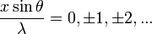,
and are half a cycle out of phase when
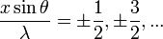
Constructive interference occurs when the waves are in phase, and destructive interference when they are half a cycle out of phase. This, an interference fringe pattern is produced, where the separation of the maxima.

Analytical Treatment of Interference of Waves
Let two similar waves of amplitudes A₁ and A₂ having same frequency and wavelength travel past a point in a medium, producing individual displacements y₁ and y₂.
Then,
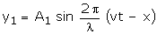
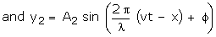,
Where f is the phase difference between the waves at the point under consideration. Then, according to the principle of superposition,
y = y₁ + y₂
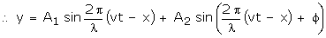
Expanding the 2nd term in the above expression using the formula, sin (A + B) = sin A cos B + cos A sin B, we get,
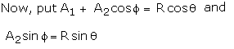 | 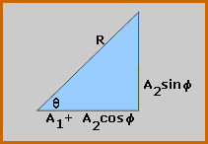

The above equation represents a simple harmonic wave of wavelength λ, velocity v and amplitude R. It differs in phase with respect to the first wave by an angle q, which can be found by referring to figure.
In this figure,
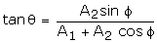, 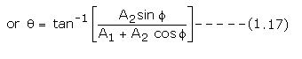
In the same figure, applying Pythagoras theorem,
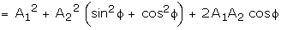
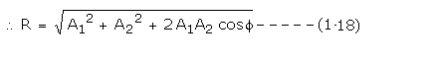
Case (i) When φ = 0, When the two waves are in phase, the resultant amplitude is given by
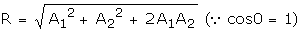
The maximum value of cosφ is 1. Thus, R will be maximum when φ = 0
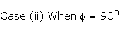, 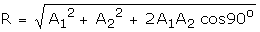
, 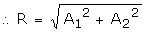, 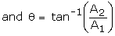
, 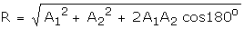
, 
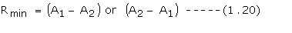

Constructive Interference: Two waves are said to interfere constructively or reinforce each other, if the resultant amplitude is maximum. The condition for constructive interference is that the phase difference 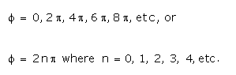
A phase difference of 2π corresponds to a path difference λ. Let the phase difference φ correspond to a path difference d.
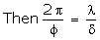, 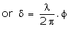
, 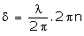, 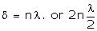
Thus, two waves will undergo constructive interference at all points at which the path difference is an even multiple of half a wavelength.

Destructive interference:Two waves are said to interfere destructively, if the resultant amplitude is minimum. This happens if
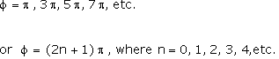
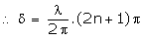, 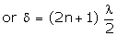
Thus, the condition for destructive interference is that the path difference should be an odd multiple of half a wavelength.

Ratio of Intensities at Maxima and Minima
It has already been proved that the intensity of a wave is proportional to the square of the amplitude. At a point where constructive interference has occurred, the intensity will be maximum and the amplitudes of the two waves will have added. If A₁ and A₂ are the amplitudes of the individual waves, then
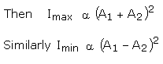
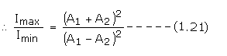
Thus, during interference of waves in a medium, the intensity will not be constant. There will be certain points of maximum intensity and certain points of minimum intensity. In other words, there will be a redistribution of energy. The energy missing at one point, exactly reappears at another point and the total energy of the medium remains unchanged.

Interference:

When two light waves from different coherent sources meet together, then the distribution of energy due to one wave is disturbed by the other. This modification in the distribution of light energy due to super- position of two light waves is called "Interference of light".
CONDITIONS FOR INTERFERENCE
The two sources of light should emit continuous waves of same wavelength and same time period i.e. the source should have phase coherence.
The two sources of light should be very close to each other.
The waves emitted by two sources should either have zero phase difference or no phase difference.
COHERENT SOURCES
Those sources of light which emit light waves continuously of same wavelength, and time period, frequency and amplitude and have zero phase difference or constant phase difference are coherent sources.
TYPES OF INTERFERENCE
..There are two types of interference.
Constructive interference.
Destructive interference.
CONSTRUCTIVE INTERFERENCE
When two light waves superpose with each other in such away that the crest of one wave falls on the crest of the second wave, and trough of one wave falls on the trough of the second wave, then the resultant wave has larger amplitude and it is called constructive interference.
CONDITIONS FOR CONSTRUCTIVE INTERFERENCE
For constructive interference, path difference between two waves is mλ
i.e. path difference = mλ
or path difference = 0, λ, 2λ, 3λ, 4λ, …..
where m = order = 0, +_1, +_2, +_3,…..
EFFECTS

Diffraction refers to various phenomena which occur when a wave encounters an obstacle. Diffraction is the slight bending of light as it passes around the edge of an object. The amount of bending depends on the relative size of the wavelength of light to the size of the opening. If the opening is much larger than the light's wavelength, the bending will be almost unnoticeable

Single-slit diffraction
We can continue this reasoning along the entire height of the slit to conclude that the condition for destructive interference for the entire slit is the same as the condition for destructive interference between two narrow slits a distance apart that is half the width of the slit. The path difference is given by 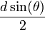so that the minimum intensity occurs at an angle θ_{min} given by
where
- d is the width of the slit,
- θ_{min} is the angle of incidence at which the minimum intensity occurs, and
- λ is the wavelength of the light
A similar argument can be used to show that if we imagine the slit to be divided into four, six, eight parts, etc., minima are obtained at angles θ_{n} given by
where
- n is an integer other than zero.

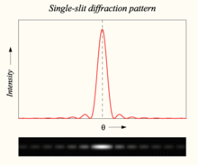
Graph and image of single-slit diffraction
A long slit of infinitesimal width which is illuminated by light diffracts the light into a series of circular waves and the wavefront which emerges from the slit is a cylindrical wave of uniform intensity.
A slit which is wider than a wavelength produces interference effects in the space downstream of the slit. These can be explained by assuming that the slit behaves as though it has a large number of point sources spaced evenly across the width of the slit.

Diffraction grating
A diffraction grating is an optical component with a regular pattern. The form of the light diffracted by a grating depends on the structure of the elements and the number of elements present, but all gratings have intensity maxima at angles θ_{m} which are given by the grating equation
where
- θ_{i} is the angle at which the light is incident,
- d is the separation of grating elements, and
- m is an integer which can be positive or negative.
The light diffracted by a grating is found by summing the light diffracted from each of the elements, and is essentially a convolution of diffraction and interference patterns.
The figure shows the light diffracted by 2-element and 5-element gratings where the grating spacings are the same; it can be seen that the maxima are in the same position, but the detailed structures of the intensities are different.
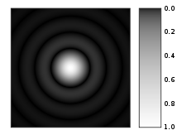
A computer-generated image of an Airy disk
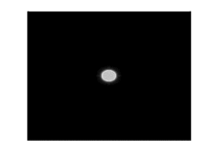
Computer generated light diffraction pattern from a circular aperture of diameter 0.5 micrometre at a wavelength of 0.6 micrometre (red-light) at distances of 0.1 cm – 1 cm in steps of 0.1 cm. One can see the image moving from the Fresnel region into the Fraunhofer region where the Airy pattern is seen.
DIFFRACTION OF LIGHT

The bending and spreading of light waves around sharp edges or corner or
through small openings is called Diffraction of Light.
CONDITIONS FOR DIFFRACTION

Diffraction of Light:
Diffraction effect depends upon the size of obstacle. Diffraction of light takes place if the size of obstacle is comparable to the wavelength of light.
Light waves are very small in wavelength, i.e. from 4 x 10-7 m to 7 x 10-7 m. If the size of opening or obstacle is near to this limit, only then we can observe the phenomenon of diffraction.
TYPES OF DIFFRACTION
Diffraction of light can be divided into two classes: Fraunhoffer diffraction.
Fresnel diffraction.
FRAUNHOFFER DIFFRACTION
In Fraunhoffer diffraction,
Source and the screen are far away from each other.
Incident wave fronts on the diffracting obstacle are plane.
Diffracting obstacle give rise to wave fronts which are also plane.
Plane diffracting wave fronts are converged by means of a convex lens to produce diffraction pattern.
FRESNEL DIFFRACTION
In Fresnel diffraction,
Source and screen are not far away from each other.
Incident wave fronts are spherical.
Wave fronts leaving the obstacles are also spherical.
Convex lens is not needed to converge the spherical wave fronts.
DIFFRACTION GRATING
A diffraction grating is an optical device consists of a glass or polished metal surface over which thousands of fine, equidistant, closely spaced parallel lines are been ruled.
For latest information , free computer courses and high impact notes visit : www.citycollegiate.com
PRINCIPLE
Its working principle is based on the phenomenon of diffraction. The space between lines act as slits and these slits diffract the light waves there by producing a large number of beams which interfere in such away to produce spectra.
GRATING ELEMENT
www.citycollegiate.com
Distance between two consecutive slits(lines) of a grating is called grating element. If 'a' is the separation between two slits and 'b' is the width of a slit, then grating element 'd' is given by;
d = a + b
_{OR}
d = length of grating/no. of lines
DETERMINATION OF
WAVE LENGTH OF LIGHT
BY DIFFRACTION GRATING
Consider two parallel rays of light r1 and r2 falling on a grating .After passing through slits they are diffracted and brought to focus on a screen at point B by using a convex lens.. Draw a perpendicular 'pq' from P on r1. Ray (1) covers a distance "rq" more than ray (2).
Now consider right angled Δrpq
rq/rp = sinθ
Or rq= rp sinθ
But rp = (a+b)
(a+ b ) = d (grating element)
rq = dsinθ -----(1)
Where rq= path difference of r1 and r2.
We know that for constructive interference at point 'B', path difference between r1 and r2 will be 0, λ, 2λ, 3λl, …….,mλl.
Therefore, rq = mλ for bright point
Putting this value in equation (1), we get
mλ = dsinθ where m = order
This equation is called "grating equation" and is used to determine he wavelength of light.
CONCLUSION
www.citycollegiate.com
'm' is called the order of grating and it is the number of bright or dark fringe obtained on the screen.
For m=0 , θ=0, central bright maxima of zeroth order.
m=1 , θ=θ1, 1st order bright maxima (path difference = λ)
m=2 , θ=θ2, 2nd order bright maxima (path difference = 2λ)
With the increase in 'm', fringes of decreasing width and less brightness are obtained.
No order of line is possible at θ>90º.
CHARACTERISTICS OF
GRATING SPECTRA
Spectra of different orders are obtained symmetrically on both sides of zeroth order image.
Spectral lines are almost straight and quite sharp.
Spectral colors are in the order. _{www.citycollegiate.com}
The spectral lines are more and more dispersed as we go to higher orders.
Most of the incident intensity goes to zero^{th} order and rest of it is distributed among the other orders. For latest information , free computer courses and high impact notes visit : www.citycollegiate.com

Diffraction Grating
When there is a need to separate light of different wavelengths with high resolution, then a diffraction grating is most often the tool of choice. This "super prism" aspect of the diffraction grating leads to application for measuring atomic spectra in both laboratory instruments and telescopes. A large number of parallel, closely spaced slits constitutes a diffraction grating. The condition for maximum intensity is the same as that for the double slit or multiple slits, but with a large number of slits the intensity maximum is very sharp and narrow, providing the high resolution for spectroscopic applications. The peak intensities are also much higher for the grating than for the double slit.
Polarization -A light wave that is vibrating in more than one plane is referred to as unpolarized light. It is possible to transform unpolarized light into polarized light. Polarized light waves are light waves in which the vibrations occur in a single plane. The process of transforming unpolarized light into polarized light is known as polarization. There are a variety of methods of polarizing light. The four methods discussed on this page are:
- Polarization by Transmission
- Polarization by Reflection
- Polarization by Refraction
- Polarization by Scattering

Polarization
A light wave is an electromagnetic wave that travels through the vacuum of outer space. Light waves are produced by vibrating electric charges. The nature of such electromagnetic waves is beyond the scope of The Physics Classroom Tutorial. For our purposes, it is sufficient to merely say that an electromagnetic wave is a transverse wave that has both an electric and a magnetic component.
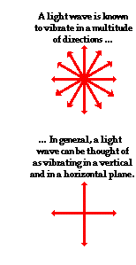
The transverse nature of an electromagnetic wave is quite different from any other type of wave that has been discussed in The Physics Classroom Tutorial. Let's suppose that we use the customary slinky to model the behavior of an electromagnetic wave. As an electromagnetic wave traveled towards you, then you would observe the vibrations of the slinky occurring in more than one plane of vibration. This is quite different than what you might notice if you were to look along a slinky and observe a slinky wave traveling towards you. Indeed, the coils of the slinky would be vibrating back and forth as the slinky approached; yet these vibrations would occur in a single plane of space. That is, the coils of the slinky might vibrate up and down or left and right. Yet regardless of their direction of vibration, they would be moving along the same linear direction as you sighted along the slinky. If a slinky wave were an electromagnetic wave, then the vibrations of the slinky would occur in multiple planes. Unlike a usual slinky wave, the electric and magnetic vibrations of an electromagnetic wave occur in numerous planes. A light wave that is vibrating in more than one plane is referred to as unpolarized light. Light emitted by the sun, by a lamp in the classroom, or by a candle flame is unpolarized light. Such light waves are created by electric charges that vibrate in a variety of directions, thus creating an electromagnetic wave that vibrates in a variety of directions. This concept of unpolarized light is rather difficult to visualize. In general, it is helpful to picture unpolarized light as a wave that has an average of half its vibrations in a horizontal plane and half of its vibrations in a vertical plane.
A light wave that is vibrating in more than one plane is referred to as unpolarized light.It is possible to transform unpolarized light into polarized light. Polarized light waves are light waves in which the vibrations occur in a single plane. The process of transforming unpolarized light into polarized light is known as polarization. There are a variety of methods of polarizing light. The four methods discussed on this page are:
- Polarization by Transmission
- Polarization by Reflection
- Polarization by Refraction
- Polarization by Scattering

Polarization by Use of a Polaroid Filter
The most common method of polarization involves the use of a Polaroid filter. Polaroid filters are made of a special material that is capable of blocking one of the two planes of vibration of an electromagnetic wave. (Remember, the notion of two planes or directions of vibration is merely a simplification that helps us to visualize the wavelike nature of the electromagnetic wave.) In this sense, a Polaroid serves as a device that filters out one-half of the vibrations upon transmission of the light through the filter. When unpolarized light is transmitted through a Polaroid filter, it emerges with one-half the intensity and with vibrations in a single plane; it emerges as polarized light.
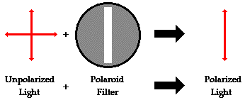

A Polaroid filter is able to polarize light because of the chemical composition of the filter material. The filter can be thought of as having long-chain molecules that are aligned within the filter in the same direction. During the fabrication of the filter, the long-chain molecules are stretched across the filter so that each molecule is (as much as possible) aligned in say the vertical direction. As unpolarized light strikes the filter, the portion of the waves vibrating in the vertical direction are absorbed by the filter. The general rule is that the electromagnetic vibrations that are in a direction parallel to the alignment of the molecules are absorbed.
The alignment of these molecules gives the filter a polarization axis. This polarization axis extends across the length of the filter and only allows vibrations of the electromagnetic wave that are parallel to the axis to pass through. Any vibrations that are perpendicular to the polarization axis are blocked by the filter. Thus, a Polaroid filter with its long-chain molecules aligned horizontally will have a polarization axis aligned vertically. Such a filter will block all horizontal vibrations and allow the vertical vibrations to be transmitted (see diagram above). On the other hand, a Polaroid filter with its long-chain molecules aligned vertically will have a polarization axis aligned horizontally; this filter will block all vertical vibrations and allow the horizontal vibrations to be transmitted.
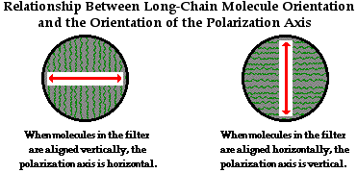
Polarization of light by use of a Polaroid filter is often demonstrated in a Physics class through a variety of demonstrations. Filters are used to look through and view objects. The filter does not distort the shape or dimensions of the object; it merely serves to produce a dimmer image of the object since one-half of the light is blocked as it passed through the filter. A pair of filters is often placed back to back in order to view objects looking through two filters. By slowly rotating the second filter, an orientation can be found in which all the light from an object is blocked and the object can no longer be seen when viewed through two filters. What happened? In this demonstration, the light was polarized upon passage through the first filter; perhaps only vertical vibrations were able to pass through. These vertical vibrations were then blocked by the second filter since its polarization filter is aligned in a horizontal direction. While you are unable to see the axes on the filter, you will know when the axes are aligned perpendicular to each other because with this orientation, all light is blocked. So by use of two filters, one can completely block all of the light that is incident upon the set; this will only occur if the polarization axes are rotated such that they are perpendicular to each other.
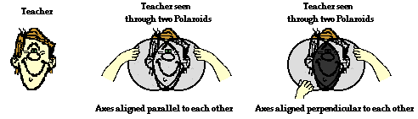
A picket-fence analogy is often used to explain how this dual-filter demonstration works. A picket fence can act as a polarizer by transforming an unpolarized wave in a rope into a wave that vibrates in a single plane. The spaces between the pickets of the fence will allow vibrations that are parallel to the spacings to pass through while blocking any vibrations that are perpendicular to the spacings. Obviously, a vertical vibration would not have the room to make it through a horizontal spacing. If two picket fences are oriented such that the pickets are both aligned vertically, then vertical vibrations will pass through both fences. On the other hand, if the pickets of the second fence are aligned horizontally, then the vertical vibrations that pass through the first fence will be blocked by the second fence. This is depicted in the diagram below.
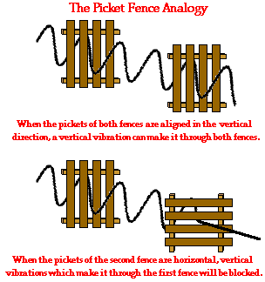
In the same manner, two Polaroid filters oriented with their polarization axes perpendicular to each other will block all the light. Now that's a pretty cool observation that could never be explained by a particle view of light.

Polarization by Reflection
Unpolarized light can also undergo polarization by reflection off of nonmetallic surfaces. The extent to which polarization occurs is dependent upon the angle at which the light approaches the surface and upon the material that the surface is made of. Metallic surfaces reflect light with a variety of vibrational directions; such reflected light is unpolarized. However, nonmetallic surfaces such as asphalt roadways, snowfields and water reflect light such that there is a large concentration of vibrations in a plane parallel to the reflecting surface. A person viewing objects by means of light reflected off of nonmetallic surfaces will often perceive a glare if the extent of polarization is large. Fishermen are familiar with this glare since it prevents them from seeing fish that lie below the water. Light reflected off a lake is partially polarized in a direction parallel to the water's surface. Fishermen know that the use of glare-reducing sunglasses with the proper polarization axis allows for the blocking of this partially polarized light. By blocking the plane-polarized light, the glare is reduced and the fisherman can more easily see fish located under the water.
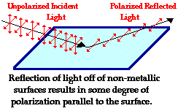

Polarization by Refraction
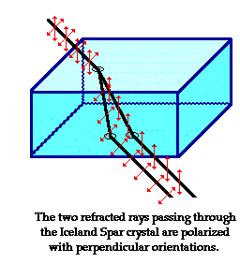
Polarization can also occur by the refraction of light. Refraction occurs when a beam of light passes from one material into another material. At the surface of the two materials, the path of the beam changes its direction. The refracted beam acquires some degree of polarization. Most often, the polarization occurs in a plane perpendicular to the surface. The polarization of refracted light is often demonstrated in a Physics class using a unique crystal that serves as a double-refracting crystal. Iceland Spar, a rather rare form of the mineral calcite, refracts incident light into two different paths. The light is split into two beams upon entering the crystal. Subsequently, if an object is viewed by looking through an Iceland Spar crystal, two images will be seen. The two images are the result of the double refraction of light. Both refracted light beams are polarized - one in a direction parallel to the surface and the other in a direction perpendicular to the surface. Since these two refracted rays are polarized with a perpendicular orientation, a polarizing filter can be used to completely block one of the images. If the polarization axis of the filter is aligned perpendicular to the plane of polarized light, the light is completely blocked by the filter; meanwhile the second image is as bright as can be. And if the filter is then turned 90-degrees in either direction, the second image reappears and the first image disappears. Now that's pretty neat observation that could never be observed if light did not exhibit any wavelike behavior.

Polarization by Scattering
Polarization also occurs when light is scattered while traveling through a medium. When light strikes the atoms of a material, it will often set the electrons of those atoms into vibration. The vibrating electrons then produce their own electromagnetic wave that is radiated outward in all directions. This newly generated wave strikes neighboring atoms, forcing their electrons into vibrations at the same original frequency. These vibrating electrons produce another electromagnetic wave that is once more radiated outward in all directions. This absorption and reemission of light waves causes the light to be scattered about the medium. (This process of scattering contributes to the blueness of our skies, a topic to be discussed later.) This scattered light is partially polarized. Polarization by scattering is observed as light passes through our atmosphere. The scattered light often produces a glare in the skies. Photographers know that this partial polarization of scattered light leads to photographs characterized by a washed-out sky. The problem can easily be corrected by the use of a Polaroid filter. As the filter is rotated, the partially polarized light is blocked and the glare is reduced. The photographic secret of capturing a vivid blue sky as the backdrop of a beautiful foreground lies in the physics of polarization and Polaroid filters.

Applications of Polarization
Polarization has a wealth of other applications besides their use in glare-reducing sunglasses. In industry, Polaroid filters are used to perform stress analysis tests on transparent plastics. As light passes through a plastic, each color of visible light is polarized with its own orientation. If such a plastic is placed between two polarizing plates, a colorful pattern is revealed. As the top plate is turned, the color pattern changes as new colors become blocked and the formerly blocked colors are transmitted. A common Physics demonstration involves placing a plastic protractor between two Polaroid plates and placing them on top of an overhead projector. It is known that structural stress in plastic is signified at locations where there is a large concentration of colored bands. This location of stress is usually the location where structural failure will most likely occur. Perhaps you wish that a more careful stress analysis were performed on the plastic case of the CD that you recently purchased.
Polarization is also used in the entertainment industry to produce and show 3-D movies. Three-dimensional movies are actually two movies being shown at the same time through two projectors. The two movies are filmed from two slightly different camera locations. Each individual movie is then projected from different sides of the audience onto a metal screen. The movies are projected through a polarizing filter. The polarizing filter used for the projector on the left may have its polarization axis aligned horizontally while the polarizing filter used for the projector on the right would have its polarization axis aligned vertically. Consequently, there are two slightly different movies being projected onto a screen. Each movie is cast by light that is polarized with an orientation perpendicular to the other movie. The audience then wears glasses that have two Polaroid filters. Each filter has a different polarization axis - one is horizontal and the other is vertical. The result of this arrangement of projectors and filters is that the left eye sees the movie that is projected from the right projector while the right eye sees the movie that is projected from the left projector. This gives the viewer a perception of depth.

Our model of the polarization of light provides some substantial support for the wavelike nature of light. It would be extremely difficult to explain polarization phenomenon using a particle view of light. Polarization would only occur with a transverse wave. For this reason, polarization is one more reason why scientists believe that light exhibits wavelike behavior

